PLANT REPRODUCTION QUIZ
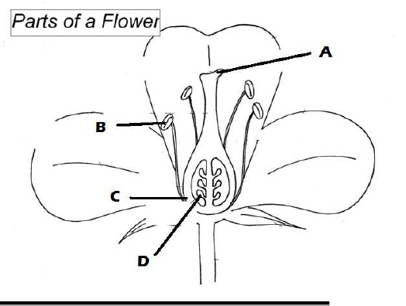
Study the diagram of a flower below carefully.1. a) Name the parts of the flower in the blanks below.
A: ____________________
B: ____________________
C: ____________________
D: ____________________
b) What is the function of A and B?
A: ________________________________________________
___________________________________________________
B: ________________________________________________
___________________________________________________

2. Using the helping words below, fill in the blanks of the cycle.
Fertilisation Germination Pollination Seed dispersal
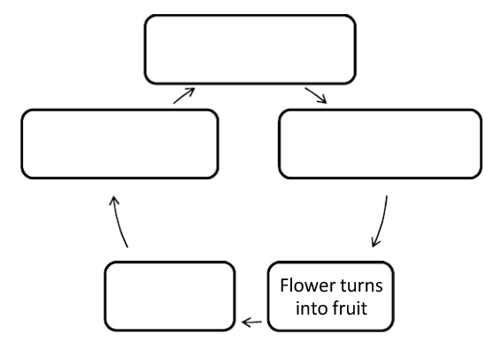

3. Describe the process of fertilization, starting from the point where the pollen grain lands on the stigma.
______________________________________________________________________ ______________________________________________________________________ ______________________________________________________________________
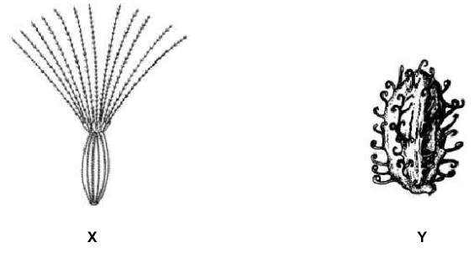
4. Study the 2 different types of seed, X and Y.
a) State the type of dispersal for each seed.
X: _______________
Y: _______________
b) Give reasons to justify your answer in (a) ______________________________________________________________________
(b) ______________________________________________________________________

